**E-Commerce website**

**A PROJECT REPORT**

***SUBMITTED BY***

**Aditya Kumar Das- 200301120144**

**P. Sudip Kumar Prusty- 200301120183**

**Soumya Ranjan Nayak- 200301120175**

**Lalatendu Bidyadhar Samal- 200301120148**

***In partial fulfilment for the award of the degree***

***Of***

**BACHELOR OF TECHNOLOGY**

*IN*

**COMPUTER SCIENCE AND ENGNIEERING**



**CENTURION UNIVERSITY OF TECHNOLOGY AND MANAGEMENT,**

**BATCH 2020-24**

***DEPARTMENT OF COMPUTER SCIENCE AND ENGINEERING***

BONAFIDE CERTIFICATE

Certified that this project report “**E-Commerce Website***”* is the Bonafide work of “P. Sudip Kumar Prusty, Lalatendu Bidyadhar Samal , Aditya Kumar Das & Soumya Ranjan Nayak” who carried out the project work under my supervision. This is to further certify to the best of my knowledge that this project has not been carried out earlier in this institute and the university

***Prof. Nilamadhab Dash***

SIGNATURE SUPERVISOR

## ACKNOWLEDGEMENT

This project would be incomplete without acknowledging the help provided by the faculty members of the Department of CSE, CUTM. We would like to express gratitude and extend sincere thanks to the respected Dean Prasanta Mohanty, CUTM, Bhubaneswar and Prof. Nilamadhab Dash for giving us the opportunity of working on the present project

We are thankful to all those who have helped us and guided us in making this project successful. We are also thankful to the staff of the Department of Computer Science without whose help and suggestions, none of this would’ve been possible

Table Of Contents

1. **Introduction**
2. **Description**
3. **Features**
4. **Requirement**
5. **Objective**
6. **Output**
7. **Policy Implications**
8. **Conclusion**

INTRODUCTION

Now a days the lifestyle of the people is different. People feel uncomfortable and time consuming for going crowded markets. The online shopping platform helps you to purchase goods and services online by mobile, or computers. Shoppers can visit web stores from the comfort of their house and shop as by sitting in front of the computer.

Online stores are usually available 24 hours a day. One of the most enticing factors about online shopping, particularly during holiday season is, it alleviates the need to wait in long lines or search from a store for a particular item. Consumers can get full information about the product with its reviews being passed by the existing users.

FORMULATION OF PROJECT

**Objective**

->The objectives of online shopping are pre-defined on which the whole system work to achieve them by managing the details of all customers, payments, bills, products, shopping, and so on.

* To shop wile in the comfort of your own home, without having to step out of the door
* To be able to easily save money and compare prices from website to website
* Online resellers tent to sell at a lower price due to less overhead expenses

## Tools Used-;

HARDWARE REQUIRED

* Printer, to print the required documents of the project
* Compact Drive
* Processor : Intel
* Ram : 512 MB or more than 512MB
* Hard disk : 80 GB or more than 80GB

SOFTWARE REQUIRED

* Operating system: Windows 10 or more
* Programming : Notepad or visual studio code
* Formspree
* Microsoft PowerPoint

Interface

**Home Page**

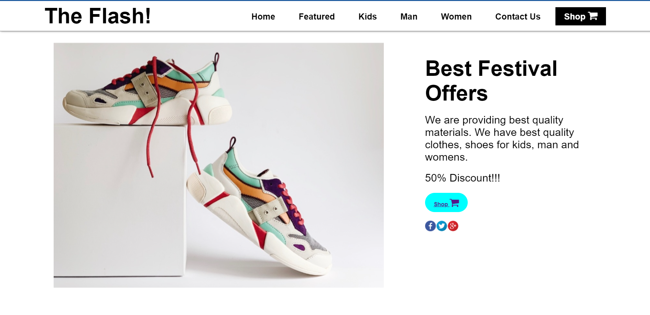

**Featured** 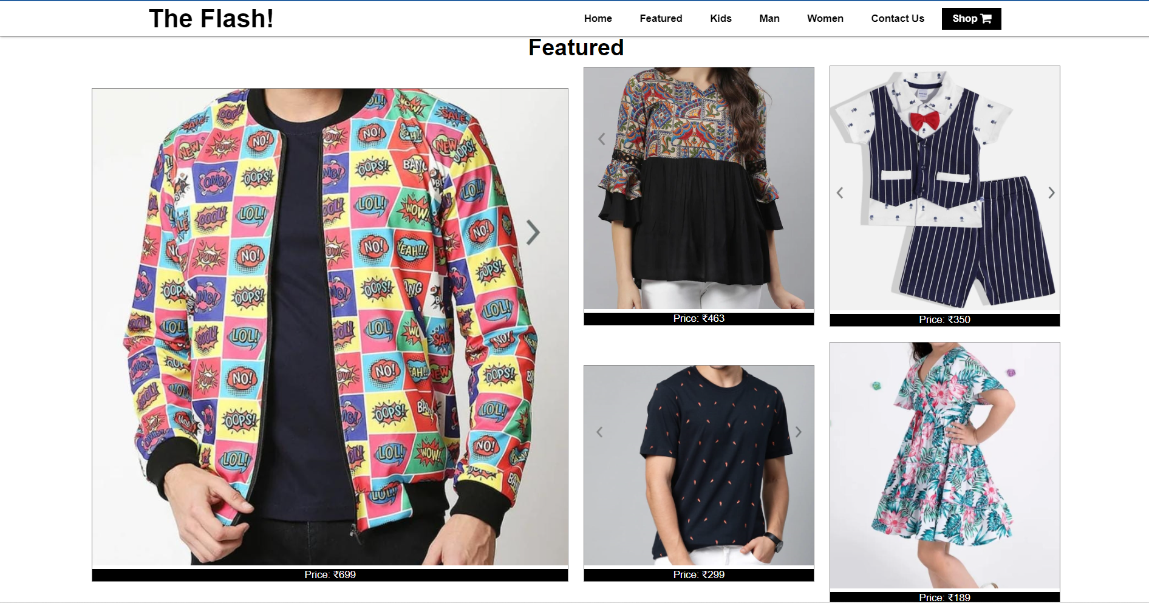

**Men’s section**

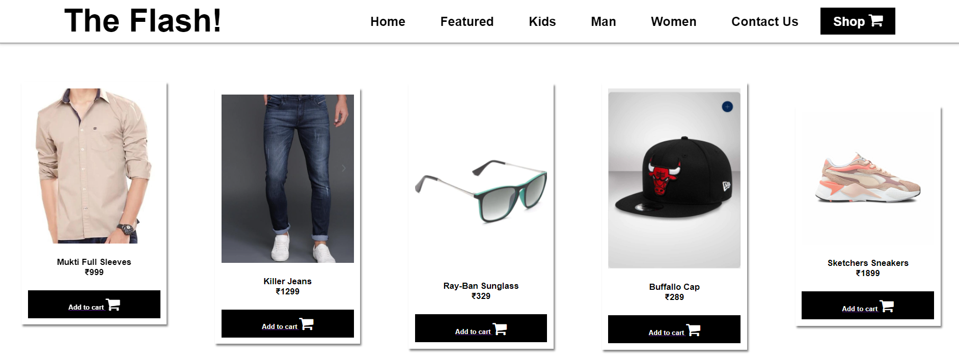

**Kids Section**

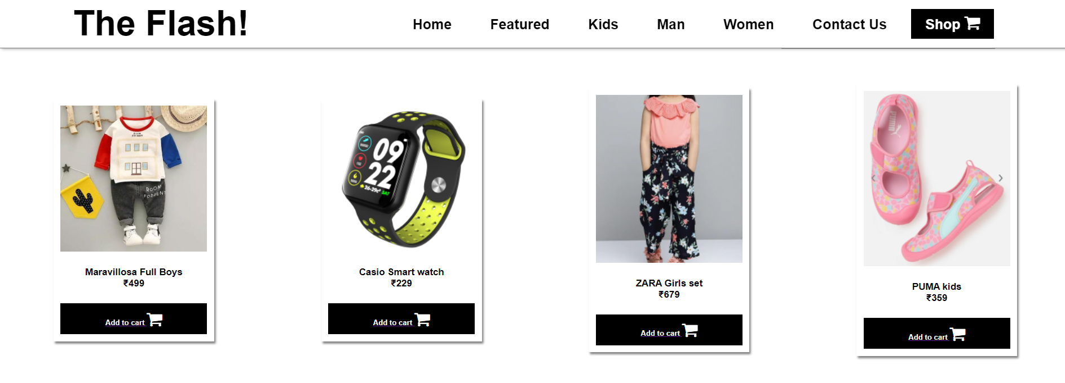

**Women’s section**

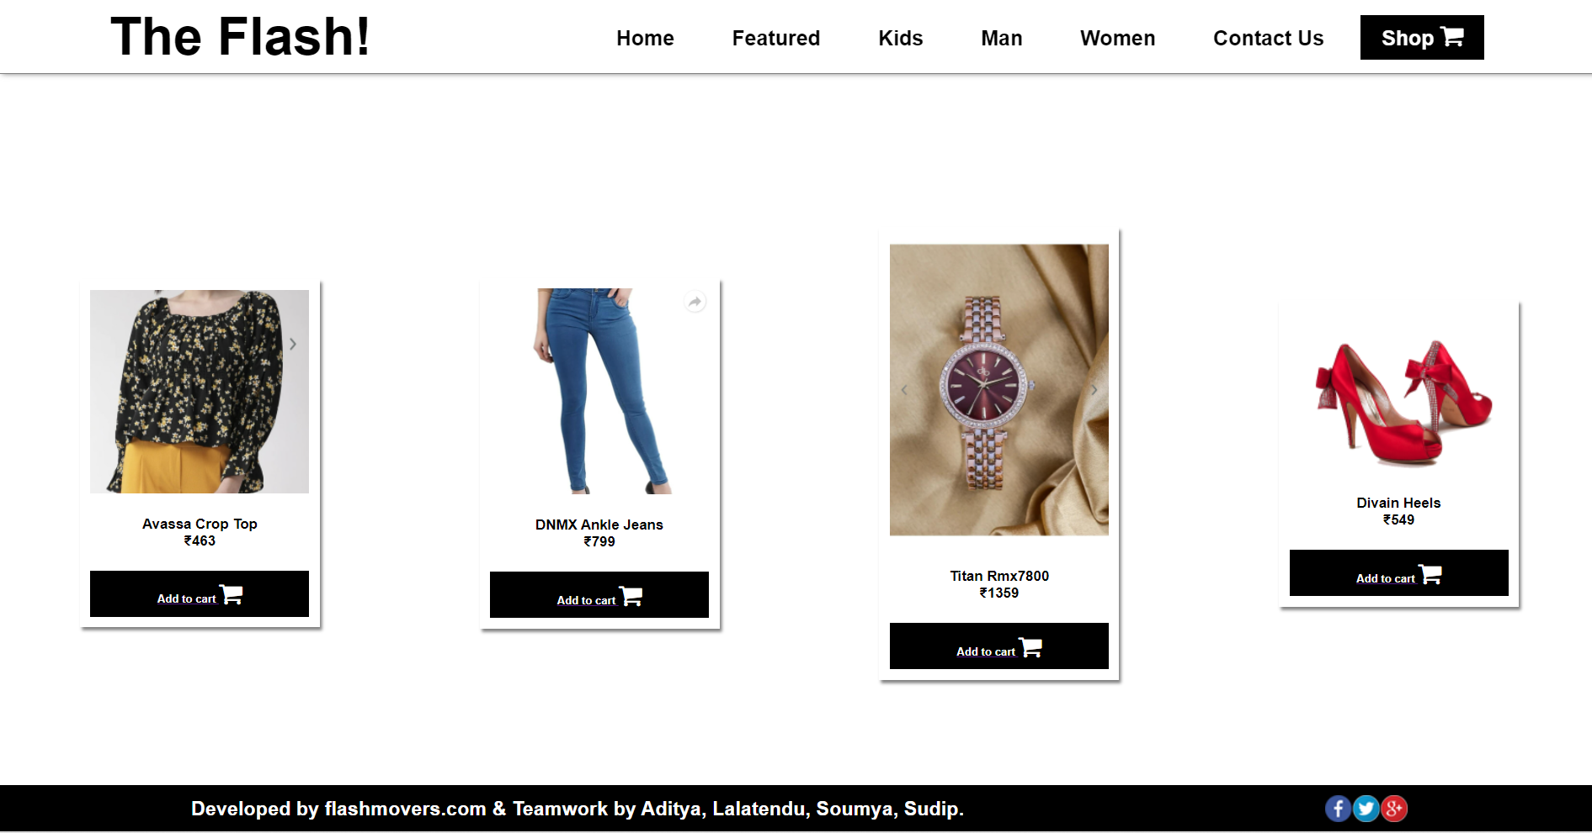

**Payment section**

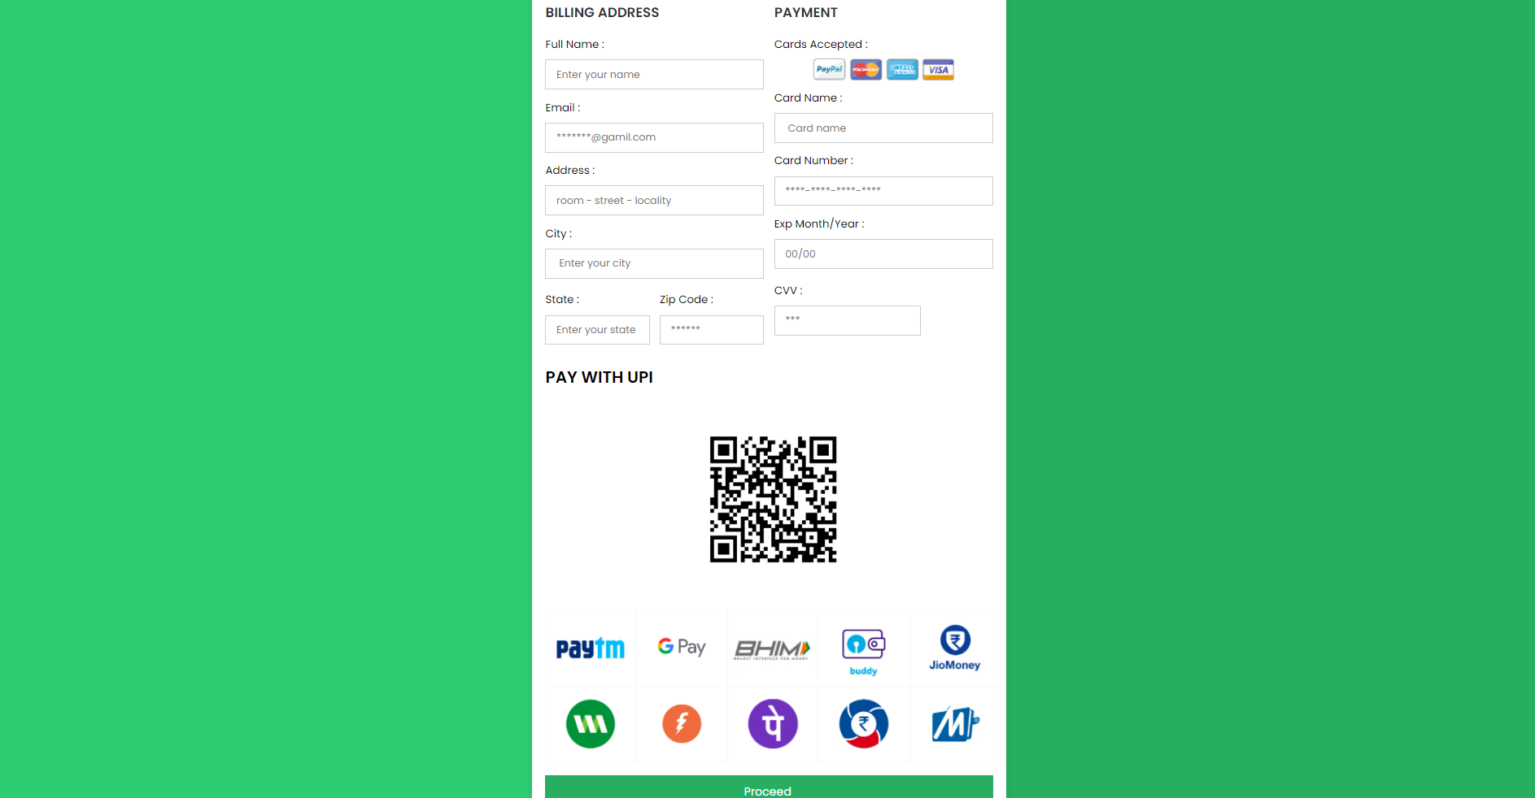

**Contact us**

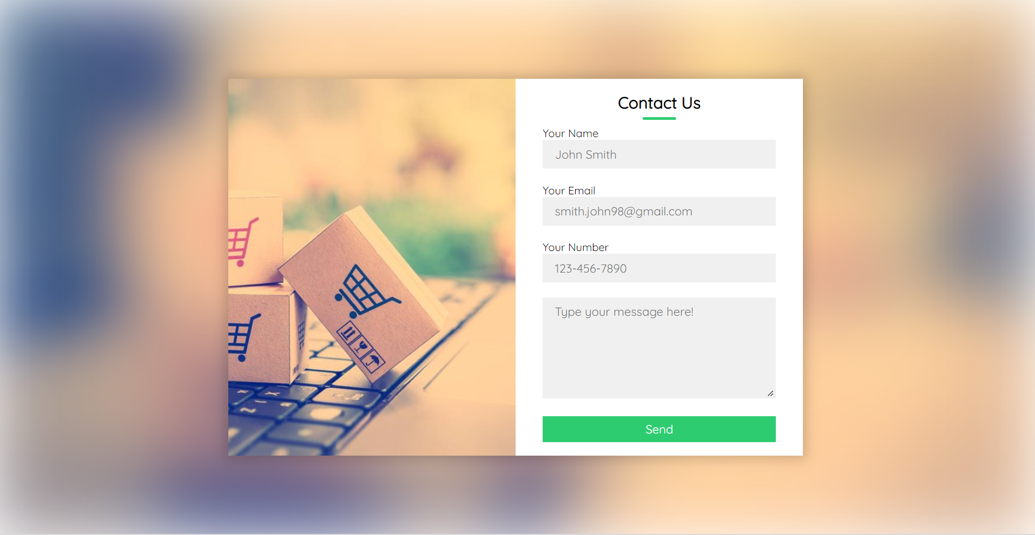

**Form Details**

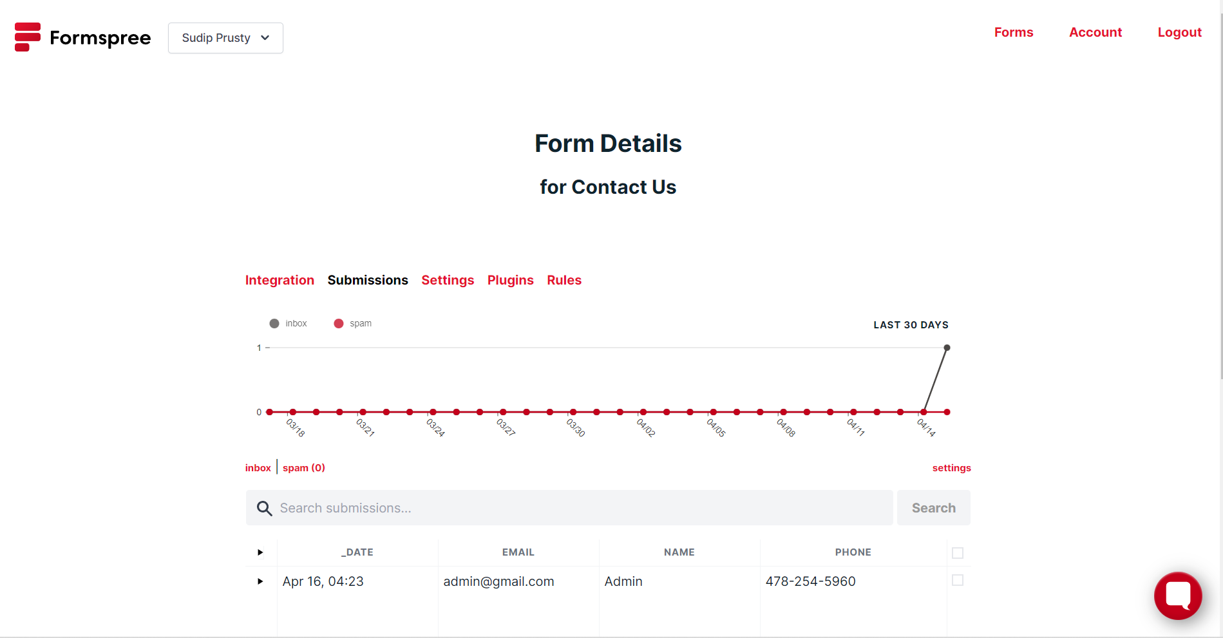

Conclusion

E-commerce still represents one of the business methods that take advantage if done the right way, even if the stock market and commodities fell, but E-Commerce still able to survive and receive high transaction.

E-Commerce has undeniably become an important part of our society. The successful companies of the future will be those that take E-Commerce seriously, dedicating sufficient resources to its development. E-Commerce is not an IT issue but a whole business undertaking. Companies that use it as a reason for completely re-designing their business processes are likely to reap the greatest benefits. Moreover, E-Commerce is a helpful technology that gives the consumer access to business and companies all over the world.

… Thank You …